rgk
PUBLIC NOTICE SK-8/2/1-043/2024/2025
SEKHUKHUNE
Distriot Municipality
Privat• Bag X8611 Groblersdal 0470. 3 West Street Groblersdal 0470
Tpl .(11 1) 70 MO. Far- (COI') 7A) USA
E-Mail : sekinfo@sekhukhunexcaa
PUBLIC NOTICE: SK-8/211-043/202412025
IN TERMS OF SEKHUKHUNE DISTRICT MUNICIPALITY SUPPLY CHAIN MANAGEMENT POLICY,
QUOTATIONS ARE HEREBY INVITED FROM ELIGIBLE AND INTERESTED COMPANIES,
CONSORTIUM OR JOINT VENTURES WITHIN SEKHUKHUNE DISTRICT REGION TO APPOINT
SERVICE PROVIDER TO SERVICE/MAINTAIN AND INSTALL FIRE REELS

Workplace | Servicing and maintenance of complete fire hose reels | Installation of complete fire hose reels and accessories | Co-ordinates
West street-Groblersdal | 01 | 0 | -25.167847671074274,
 |  |  | 29.38765189569933
AB Skosana fire station- | 07 | 03 | -25.16216782291017,
Groblersdal |  |  | 29.410955573847954
Fetakgomo | 03 | 0 | -24.423796514749956,
(Mashilabela fire station) |  |  | 29.789626406433264
Tubatse Fire Station | 04 | 0 | -24.653169045231195,
 |  |  | 30.352604295841683
Total | 15 | 03

Fully Completed quotation documents, Priced, and initialed each page must be placed in a sealed envelope and marked (REQUEST FOR QUOTATIONS TO SERVICE/MAINTAIN AND INSTALL FIRE REELS.) deposited in a tender box at Groblersdal Fire Station by no later than 11h00 on 22 January 2025. No compulsory briefing session will be held. For further information, contact Voster Masemola of SCM on 013 262 7656 or Linda Sekhukhune of CPS on 013 262 7300.
Please note:
The following returnable documents are compulsory and will lead to disqualification if not attached.
- Tax Compliance Status Pin/Tax Clearance Certificate
- Valid Copy of Company Registration documents
- Original Certified ID copies of Directors (Not older than 3 months)

- Proof of municipal rates and taxes for both company and Director(s) not in arrears for more than three months or proof of lease agreement including rates for the landlord. In case where the Company or Director is registered in a rural area where the rates are not paid, please attach proof from Local Authority and affidavit under oath indicating that there are no municipal rates payable.
PUBLIC NOTICE SK-8/2/1-043/2024/2025
- MBD 4, MBD 8, MBD 9 and MBD 6.1 forms must be signed and attached with quotation.
- CSD Summary Report.
- Any alterations must be signed. ((NB: not initialed)
- Telegraphic, facsimile, e-mailed, Copy and telex bids will be not accepted.
- No late bids will be accepted.
Evaluation Criteria
- A preferential points system shall apply whereby the points will be allocated in accordance with the Preferential procurement Regulations of 2022, where 80 points will be allocated in respect of price and 20 points in respect of preference points claimed for attainment of other specified goals summarized as follows:
HDI SPECIFIC GOALS | POINTS
HDI (Blacks, Indians and Coloureds) | 12
Woman-Ownership of more than 50% | 2
Disability ownership of more than 50%(Physically impaired) | 2
Youth | 2
Locality | 2
Total | 20

 | 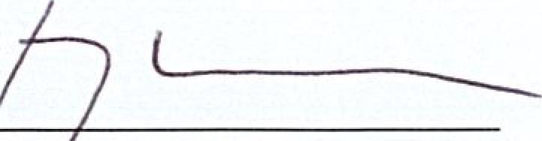 | (3 (0  Date
Mr. KG ALE M.M MUNI PAL MANAGER |  | (3 (0  Date

